Instructions For the IITFC Online Examination

- HOW TO START THE IITTM IITFC BASIC IBT:
  - Open the online examination link using either Google Chrome or Mozilla Firefox in your desktop/laptop ONLY.
  - Login with your Unique ID/ Registered mail ID and Date of Birth.

Note: The online examination link will be shared via email notification and on the IITFC web portal.

- You will be continuously monitored through the mic and webcam (audio-video) during the test session both by the human proctor and the AI-based software, and the test proceedings will be recorded for analysis later if deemed necessary. Your computer screen too will be similarly monitored and recorded.
- As soon as the Approver authorizes you, your test will start and the test timer will begin.
- You have to follow the instructions given by the proctor.
- Upon being requested you need to formally give your consent to the proctor to monitor your computer screen and also lock-up a few files for the test duration only.
- You have to follow the instructions of the proctor conveyed through the chat box, such as to show a 360-degree view of the test room, etc. as and when instructed.
- The questions on your computer screen will appear in Bilingual (English/ Hindi).
- Every question is followed by 4 answer options. Choose the option that is most appropriate and indicate your answer by clicking on the circle/box adjacent to that option.
- You can go to any question directly by clicking on the question number within the section.
- If you are doubtful of the answer, you can mark a question for "Revisit", this can be removed manually by clicking on it once you come back to the same question at a later time.
- For IIFTC basic main Internet Based Test You need to complete Section A within allotted time of 45 minutes as Section B will automatically start after 45 minutes/ duration of Section A.
- If you have opted for additional State module duration of exam will be of 45 minutes
- If you want to change your answer to any question, you may select the question and change the answer by clicking on the appropriate answer.
- Timer display at the top of the screen indicates the time remaining for you throughout the test.
- In case you finish your test before the allotted time, you will get a confirmation page which will give you two options - either to go back to the test or to finish/submit the test. In case you want to review the answers in the remaining time you can do so; else, you may finish the test and proceed to submit.
- Once you submit, you cannot go back to the test.

SYSTEM REQUIREMENT FOR UNDERTAKING INTERNET BASED TEST
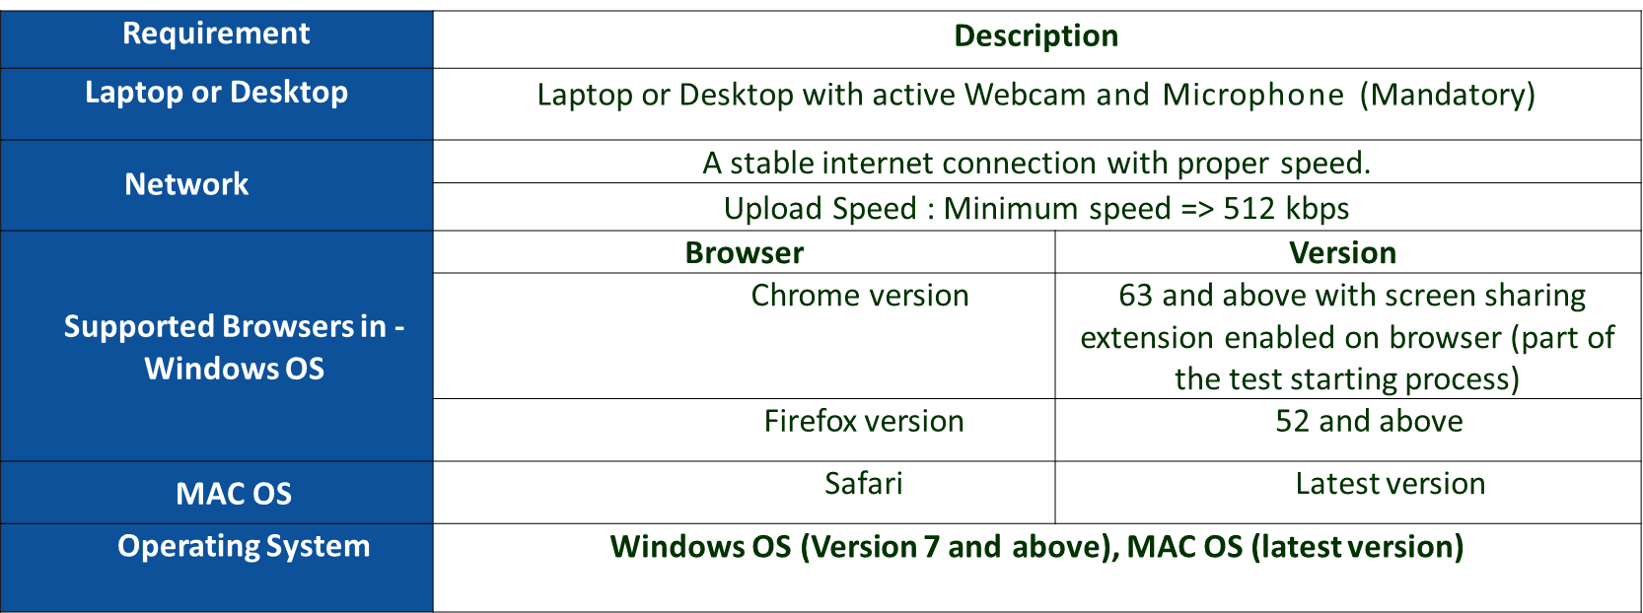

THOROUGHLY READ THE FOLLOWING DOs and DON'Ts FOR CANDIDATES:
- Ensure to have a stable internet connection for uninterrupted test experience.
- Do not press "F5" during the test at any time as doing so will cause your test to finish abruptly.
- On the registration page, you shall be required to enter the correct email address to start the test. In case if you are not entering email address in correct format you shall get a notification “Email address is not authorized for this test".
- You must keep a valid original Photo ID which you have uploaded in your examination form, such as (i) Voter ID Card / PAN Card/ Driving License / Aadhaar Card/ Passport handy before the start of the test.
- As soon as the Approver authorizes you, your test will start and the test timer will begin.
- You must keep your drinking water (in a transparent bottle only), pen/pencil and paper for rough work, ready before the start of the test.
- Ensure that items such as Mobile Phone, Electronic Gadgets, Smart/Digital Watch, Calculator, Bag, Handbag, Notes, Books, Food & Beverage items, etc. are not kept with him/her or the test room.
- Any candidate found using or to be in possession of such unauthorized material or indulging in copying or adopting unfair means is liable to be summarily disqualified. The final decision will be taken by the IITTM.
- For the authorization process you have to follow the steps below.
  - First you have to capture your own (Face) snapshot. Ensure that the snapshot must be clearly visible. There should be proper light in the room during the examination and your face is clearly visible to the proctor
  - Secondly you have to capture the snapshot of your original Photo ID card (uploaded in your examination form) in such a way that the name and the photo on the id card should be clearly visible.
  - After submitting your own (Face) snapshot and your Photo ID card, the proctor will authorize you to start the test if he/she is satisfied with the snapshots. In case he does not allow, you need to ensure that the snapshot captured is clear and you have an alternate valid Photo ID card to resubmit.
  - We request you to be patient and cooperative as this is an extremely important process. Authorization time is not part of exam time so even if it takes time, you will not lose time on the test. Test timer will only start once you are authorized.
- You will be continuously monitored by Human Proctor & Artificial Intelligence Software, use of any unfair means/ malpractice may lead to termination of your test:
  - Once the test is started, toggling between the windows is not allowed for any reason.
  - You are not allowed to use mobile phones, calculators or other devices during the test.
  - You are not allowed to move away from your seat during the test.
  - Please ensure that you are not running any remote access software before or during the test.
  - You are not allowed to connect any extended screen/projector along with the system being used during the test.
  - No one should be sitting/standing near you during the test.
  - There should be sufficient light in the room you choose to take the test from.
  - You are not allowed to lip sync or read the questions aloud.
  - Usage of any reference material.
  - Please ensure you are the only person in the room during the test and there is no disturbance. At any point of time during the test, you can be asked by the proctor through Chat, to turn your Laptop/Webcam for a 360 degree check to see your surroundings.
For All correspondence (discrepancies/ issues/ queries/ information) related to IITTM IITFC BASIC IBT please email to iitfcexammains@iittmnoida.ac.in ONLY. Email sent to other Email addresses will not be considered.

